FAO Case Officer  Katherine Fitzherbert-Green  Basingstoke and Deane Borough Council  Civic Offices,  RG21 4AH | Our Reference: ETP210402  Your Reference: 23/00205/OUT  Date: 2 March 2023

Dear Sir/Madam,

Application reference 23/00205/OUT: Outline planning application with all matters reserved except for access for up to 350 dwellings, landscaping, public open space and associated infrastructure at Land at Kiln Farm, Kiln Road, Sherborne St John, Basingstoke, RG24 9LS

I am pleased to enclose a response from Sherborne St John Parish Council who are a statutory consultee in relation to application reference 23/00205/OUT at Land at Kiln Farm. Kiln Road, Sherborne St John, Hampshire, which proposes:

“Outline planning application with all matters reserved except for access for up to 350 dwellings, landscaping, public open space and associated infrastructure’’

It is noted that a decision on whether to grant planning permission relates to an assessment of whether the scheme is in accordance with the relevant policies in the development plan, unless there are material considerations which indicate otherwise.

The conclusion of this letter is that the proposed development is harmful for a multitude of reasons, as well as undermining the emerging Local Plan and Neighbourhood Plan processes, and therefore must be refused without delay.

We object to the proposed development for the following reasons, which will be explored in detail in this letter:
- Planning Policy context
- Emerging Local Plan and Neighbourhood Plan
- What is considered to be suitable levels of development in Sherborne St John?
- Site Allocations for the Local Plan Update
- Local Plan Update Evidence Base
- Principle of development in the countryside
- Agricultural Land Classification
- Landscape impact
- Strategic Gap
- Important views
- Rural Character
- Biodiversity, Geodiversity and Nature Conservation
- Heritage Impact
- Highways and transport
- Infrastructure
- Implications of the National Planning Policy Framework changes and Levelling Up and Regeneration Bill

It is noted that after only two weeks into the process, there have already been over 200 letters of representation received including an objection from the local ward councillor. There is very strong local feeling against the proposed development.

Planning Policy context
We will firstly explore the policy context and why the proposed development is flagrantly circumventing the plan-led process.

Paragraph 15 of the National Planning Policy Framework (NPPF) requires the planning system to be plan-led, whereby plans should provide a positive vision for the future of each area, a framework for addressing housing needs and other priorities.

It is important to note that the development plan policies (which are not related to housing delivery) should still be afforded full weight, as per paragraph 11 d) of the National Planning Policy Framework, despite the Local Plan being over 5 years old.

Policy SS5 (Neighbourhood Planning) of the Local Plan is supportive of neighbourhood planning and for parishes to take ownership of the housing requirements. As part of the spatial strategy, a number of parishes were given housing figures for the relevant parishes.

The Sherborne St John Neighbourhood Plan (SSJ NP) forms part of the Development Plan, alongside the adopted Local Plan. It was adopted in May 2017 and allocated a site for 18 dwellings at Cranes Road (policy SSJ3). Subsequently the NP qualified for the additional protection given to neighbourhood plans as per paragraph 14 of the NPPF. This additional protection ended on 5 May 2019. The SSJ NP site allocation (16/04110/OUT) has now been completed with new residents now living within these homes in Sireburne Close.

Furthermore, it should be noted that the impact of windfall development on smaller settlements is far more obvious than the larger villages and towns in the borough. This is particularly pertinent when given the proposed number of dwellings for the outline application is 350 dwellings. This is well above the recommended levels of windfall allowance for smaller settlements to qualify within policy SS5 of the ALP which recommends developments of 10 or more dwellings outside but adjacent to the SPB for settlements which have not met their Policy SS5 requirement. Within the policy levels of dwellings of 10 or more outside the Settlement Policy Boundary (‘SPB’) are considered to be strategic and unsuitable for the smaller settlements listed within the policy when compared to the larger settlements in the policy who have been given development levels varying between 50-200 dwellings.

Emerging Local Plan and Emerging Neighbourhood Plan
The current Local Plan for Basingstoke and Deane Borough Council (BDBC) was adopted in May 2016. Subsequently, the Local Plan is now over five years old. BDBC have undertaken a review of their adopted Local Plan 2011-2029, to determine whether it is still relevant, and have now commenced work on their Local Plan Update (LPU).

A non-statutory Issues and Options consultation exercise was undertaken in late 2019. The LPU has subsequently been delayed due to local housing need. The current Local Development Scheme (LDS) which was updated in October 2022 states that consultation on the regulation 18 Local Plan is expected later this year, in Autumn 2023, with adoption of the new LPU expected in Autumn 2025.

Whilst there is no requirement in law for a neighbourhood plan to the reviewed, the Parish Council, as qualifying body, have commenced a review of the SSJ NP. Due to delays with the Local Plan, it is anticipated that the NP update will be adopted prior to the LPU. It is therefore important that the neighbourhood plan process is not undermined via the approval of a significant windfall sites within the parish which do not meet the policies contained within the development plan.

The development proposal was proposed to be included as a site allocation within the emerging Regulation 18 Local Plan Update, however as explained later this can be afforded no weight as the Regulation 18 consultation was never formally launched and is likely to change in response to the proposed NPPF changes. In any case the proposed development is different to that proposed through the Local Plan Update which proposed to allocate the site for approximately 240 homes.
What is considered to be suitable levels of development in Sherborne St John?
At the Council’s Economic, Planning and Housing (EPH) Committee in November 2021, a figure of 15 homes had been recommended for Sherborne St John as evidenced by a Settlement Study that the LPA had undertaken.
BDBC have recommended that the requirement for 15 new dwellings in Sherborne St John Parish is removed. Paragraph 6.4 of the Committee Report by BDBC states: ‘Further consideration has therefore been given to the impact of the proposed allocations on affected settlements in close proximity to future development. At this stage it is therefore proposed that no specific additional housing requirement be given to nearby settlements through Policy SS5, namely Old Basing, Oakley, Sherborne St John and Sherfield on Loddon. It should be noted that development within the SPBs of these settlements will continue to be supported where suitable and policy compliant, as will exception schemes that meet other policies outlined in the Plan, such as the exceptions policy for self- build homes and small-scale affordable housing schemes.’
The Council have therefore identified that as the Parish have allocated housing to meet their previous policy requirement through the NP and due to the proposed future housing in the LPU (which included the site for 240 dwellings) they should not receive any additional development which is not compliant with the development plan.
Therefore, this speculative development proposes an additional 110 dwellings which is is in breach of local policy SS1 and SS5. The proposed development is circumventing both the Local Plan and Neighbourhood Plan processes and should be refused for this reason alone.

Site Allocations for the Local Plan Update
As earlier outlined, the Council’s Regulation 18 Local Plan Update has been delayed and is expected to be consulted upon later this year. A full consultation draft of the Regulation 18 Plan has not been published or consulted upon, therefore at present, the drafts that have been to Economic, Planning and Housing (EPH) Committee can be afforded no weight.

The site was proposed to be included as an allocation in the emerging spatial strategy that went to EPH members in September 2022. However this spatial strategy was not approved by members due to the housing number for the borough being considered too high and too much development being proposed in the borough. This meant the members refused to support any sites that were proposed to be included within the spatial strategy.

Differences between the proposed allocation and planning application area
It is important to note that the submitted application is for considerably more than the draft policy which was for 240. This represents a 46% increase in the number of dwellings proposed. The evidence base supporting the Local Plan Update did not assess the impact of 350 dwellings and the impact of the larger site area.

Local Plan Update Evidence Base
The Council have published some of their evidence base for the Local Plan Update. This section will summarise the outputs of two key evidence base documents:

Strategic Housing and Economic Land Availability Assessment
The site is contained within the Council’s Strategic Housing and Economic Land Availability Assessment (SHELAA), the most recent of which was published in December 2022. The relevant reference for this site within the SHELAA is SSJ004. The proforma for the site states that the site ‘lies to the east of SSJ (approximately 500m away).’ It then notes ‘the site is adjacent to but outside the Basingstoke Settlement Policy Boundary, in a countryside location where new housing is generally only permitted as an exception, in line with current adopted Local Plan Policy SS6 (New Housing in the Countryside). The general principle of development in this location is therefore not supported by the council’s current planning framework. The site is located within the Basingstoke- Sherborne St John Strategic Gap which aims to prevent coalescence between those settlements and only permits development where it accords with the criteria set out in policy EM2.’
In terms of constraints, the SHELAA notes the following ‘There is a listed building within the Kiln Farm group of buildings to the south of the site. The woodland to the north of the site is designated as a SINC, as is a small patch of woodland on the north-western side of the site. There are likely to be landscape and ecological implications associated with the development of the site for housing’.
The SHELAA confirms that the site is unsuitable based on the current Planning Policy Framework.
Integrated Impact Assessment
A key evidence base document is the Integrated Impact Assessment (incorporating Sustainability Appraisal). The site scored poorly on a number of aspects, including use of greenfield/undeveloped land and that the site did not relate well with existing settlements in terms of their form, scale and/or character.

The site has been submitted ahead of the Local Plan Update, and proposes a larger quantum and density than assessed through the Local Plan Update. Furthermore, given that progress on the LPU has stalled and the planning application has come ahead of this process, it should be assessed independently, and should not be permitted due to the harmful impacts of development.

Principle of development in the countryside
Whilst the council’s current lack of five-year housing supply is noted. It is helpful to set out the context regarding the most relevant policies related to housing delivery if the policy were to be fully engaged.

As outlined, the Local Plan Update is not expected to be in place until at least 2025, therefore the policies in the current Local Plan form part of the development plan.

Policy SS1 sets out the spatial strategy for the borough and defines the borough’s Settlement Policy Boundaries (SPBs), it notes that any land which is located outside of the defined SPB is considered to be located in the countryside.

Policy SS6 of the ALP (new housing the countryside) is linked to the council’s spatial strategy (as set out in policy SS1) and sets out the exceptional circumstances in which residential development would be allowed in the countryside. The only relevant criterion for this site would be criterion d), which permits small scale residential proposals that meet a locally agreed need provided the relevant criterion within the policy are met. However, this proposal exceeds the threshold which the policy defines as small-scale development (being for four dwellings or fewer (net)), furthermore, no evidence of locally agreed need has been submitted and therefore the proposal would fail to meet the requirements of the policy and therefore be in conflict with the development plan.
Agricultural Land Classification
The Agricultural Land Classification (ALC) provides a framework for classifying land according to the extent to which its physical or chemical characteristics impose long- term limitations on agricultural use. The ALC system classifies land into give grades with 1 being the best and 5 being the worst.
The highest grade goes to land that:
- gives a high yield or output
- has the widest range and versatility of use
- produces the most consistent yield
- requires less input
The best and most versatile (BMV) agricultural land is graded 1 to 3a. The proposed development is located on Grade 3 land which is good to moderate quality agricultural land and therefore BMV. Planning Practice Guidance Paragraph: 001 Reference ID: 8-001-20190721 requires that planning policies and decisions should take account of the economic and other benefits of the best and most versatile agricultural land.
Furthermore, Planning authorities must consult Natural England on all non-agricultural applications that result in the loss of more than 20 hectares (ha) of BMV land if the land is not included in a development plan. This is required by schedule 4(y) of the Development Management Procedure Order 2015.
It is therefore considered that significant loss of BMV has not been justified. In addition, Natural England should be consulted upon the loss of BMV as a statutory consultee.

Landscape impact
The proposal contravenes policy SS6 which makes clear that development should respect the local landscape and be sympathetic to its character and visual quality, together with respecting the character, form and appearance of surrounding development and respect the amenities of the residents of neighbouring properties.
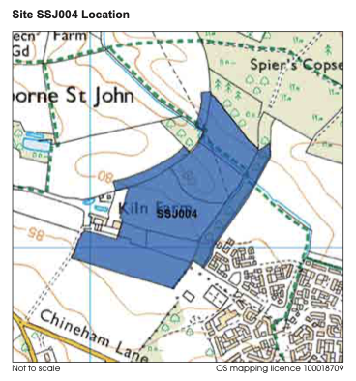
Fig 1: site area assessed within the Landscape Sensitivity Study (2021)
The council have commissioned various pieces of evidence base documents to inform their site selection process. This includes a Landscape Sensitivity Study in April 2021 which was undertaken by Hankinson Duckett Associates (HDA), the smaller SHELAA site was assessed as part of this work and found to have a medium/high landscape sensitivity score, the conclusion states that ‘this site is not appropriate for significant development from a landscape perspective’ making it unsuitable for significant housing development. The site scored highly on the visual value impact (in line with the views identified within the NP), scenic quality and settlement pattern, it particularly notes ‘The site adjoins recent development. The site adjoins recent development on the western edge of Basingstoke, although slightly detached by young belt of planting, which over time will form robust new settlement edge. The site is within the Basingstoke - Sherborne strategic gap and form a considerable portion of the landscape which helps maintain the separate identities of the two settlements’. Therefore, the smaller site has already had its landscape impact assessed and it failed based on its high landscape sensitivity.
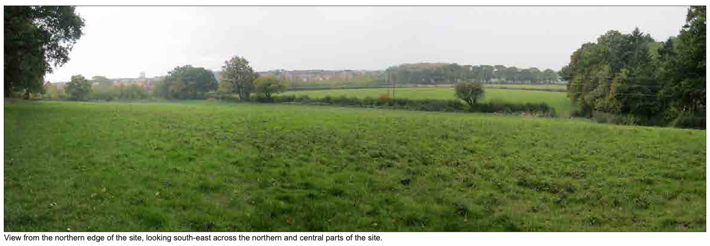
Fig 2: Photograph extract of the site from the Landscape Sensitivity Study (2021) showing the northern edge of the site, looking south-east across the northern and central parts of the site
In addition, a Landscape and Visual Impact Assessment has been submitted by the applicant to support the application, paragraph 9.3 notes ‘there would inevitably be an extensive change in character at the Site level, due to the change in land use from fields to residential led development, with new access, massing, activity, movement and lighting associated with the Proposed Development’. Paragraph 9.7 then states ‘The residential massing and associated access would result in localised changes to landform, although due to the low lying position of the Site, the underlying pattern of low lying and gently sloping landform would still be perceived’‘.
Paragraph 9.11 then notes the longer term changes to the landscape by stating ‘At year 15, the impact at the Site level would remain high, from the retained developed character and the improved vegetation structure. In relation to the high sensitivity of the Site, the effect at year 15 would reduce to moderate adverse, due to the balance between the greater integration of the massing, the remaining developed character, the improved vegetation cover and increased opportunities for biodiversity.’ Table 91 then provides a summary across a 15 year period.
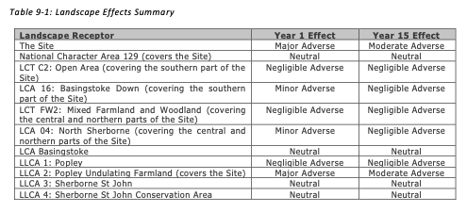
Fig 3: Summary of Landscape effects from LVIA

In summary, the proposed development will have a detrimental impact on the landscape. As has already been demonstrated through the Local Plan evidence base, this is an inappropriate location for growth. Sites have already been selected for the Parish to meet their housing need through the Neighbourhood Plan process, in locations where there is less landscape harm.

In addition, the LVIA submitted identifies the specifics of the proposals which would be harmful to the landscape by reason of the quantum, scale, design and location of the proposed development as a minimum. The development is therefore contrary to Local Plan Policies EM1, Neighbourhood Plan Policy SSJ2 and section 12 & 15 of the NPPF.

Strategic Gaps
The development proposal is located within the existing Strategic Gap area between Basingstoke and Sherborne St John as per Policy EM2 (Strategic Gaps). These were introduced to prevent coalescence of built-up areas and to maintain the separate identity of settlements. The strategic gaps are defined as generally open and undeveloped in nature.

Policy EM2 does allow three exceptions to when development can be approved within the Strategic Gap, the proposal must meet a) and then either b) or c). The criterion relate to diminishing the physical and/or visual separation (a); and it would not compromise the integrity of the gap either individually or cumulative with other existing or proposed development (b); it is proposed through a neighbourhood plan (c). It is considered that the development would not meet any of the criteria above and therefore is not policy compliant.

In addition, the principle of strategic gaps are proposed to be retained through the Local Plan Review, although it should be noted that the evidence base for this work has not yet been published.

Furthermore, as part of the Neighbourhood Plan Review, evidence is being compiled to consider designating a Local Gap within the Parish. This application therefore circumvents the NP process.

It is therefore considered that the development proposal would not meet any of the exceptions in policy EM2 and is therefore not in compliance with Policy EM2 of the Local Plan and would potentially prejudice the emerging NP process.

Important Views
Linked to the previous chapter on landscape harm and strategic gaps, the proposed development is not considered to respect visual amenity by protecting important views out of the village. This is particularly true of views from the village towards Basingstoke, a number of which go across the proposed development site.

Policy EM1 of the Local Plan requires proposals must respect, enhance and not be detrimental to the character or visual amenity of the landscape likely to be affected, paying particular regard to the setting of a settlement, including important views to, across, within and out of settlements (criterion c). Policy SSJ2 of the SSJ Neighbourhood Plan requires that development should respect visual amenity by protecting important views out of the village or towards the village, as identified within map 5 of the NP.

In addition, it is important to note that a Public Right of Way crosses through the northern part of the site and is open to public views which affect the visual amenity across the site.

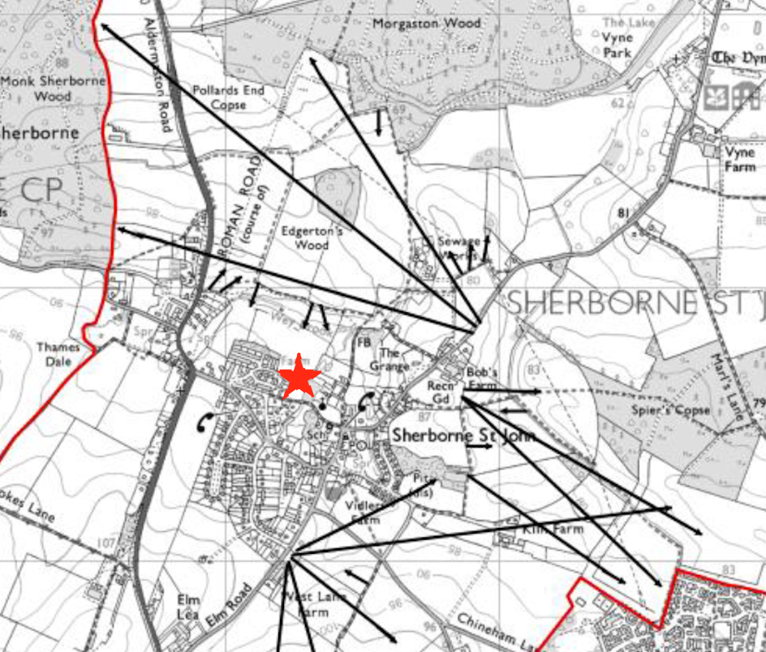
Fig 4: Sherborne St John Neighbourhood Plan 2011-2029, Map 5, Important views out of and towards the Village

It is considered that the development proposal is a contravention of Local Plan policy EM1 and EM10 and SSJ Neighbourhood Plan policy SSJ 2, due to the proposed development being detrimental to the visual amenity of views out of the settlement.

Rural character
When the Sherborne St John Neighbourhood Plan was being formulated, the ‘village feel’ of Sherborne St John was identified as having a high level of importance amongst respondents during the course of the consultation process. This was incorporated in SSJ Policy 2: The Rural Character of the Parish. Factors which characterise the village feel include – the green spaces in and around the village which provide for a low density form of development that is green in character; the level of tranquillity afforded to the village and most of the Parish due to low levels of noise and light pollution; and the abundance of flora and fauna both within the village and throughout the rural area. The Sherborne St John Village Design Statement also cites a number of important views out from and back towards the village, which are referred to in Map 5 of the Neighbourhood Plan (see Fig 1) and given full weight in SSJ Policy 2.

Part 2 of the Council’s Settlement Study notes that Sherborne St John has a population of 760 (SAPF, 2019) with approximately 353 dwellings. The additional 350 houses proposed on site would result in a significant increase in the total number of dwellings in the parish, having a considerable impact on the character of the village.

The proposal results in an unsustainable pattern of development by reason of the creation of a new unplanned large housing estate on a greenfield site in the countryside outside of settlement limits. The development is contrary to the spatial objectives of the development plan and policies – the made NP makes one allocation in Sherborne St John which has been completed.

Therefore, as well as being harmful, the proposals represent an unnecessary development (much larger than initially proposed and assessed via the emerging Local Plan). The proposals are contrary to Local Plan policies EM1 and EM10, which require new development to respect the character and visual quality of the area concerned. It is also contrary to SSJ Neighbourhood Plan policy number SSJ 2, in that the proposals are harmful to the rural character of the village and surrounding countryside and there is no justification for additional housing above that required by the made Neighbourhood Plan and emerging Local Plan.

Biodiversity, Geodiversity and Nature Conservation
Policy EM4 of the Local Plan seeks to prevent harm to biodiversity and/or geodiversity resulting from development. Two Sites of Importance for Nature Conservation (SINCs) are located adjacent to the site, these are Spiers Copse and Kiln Farm Spread.

A Preliminary Ecological Appraisal has been submitted to support the application, this makes a significant number of suggestions for mitigation. It is suggested the PEA is reviewed independently to ensure the recommendations are achievable and can be satisfactorily implemented to prevent damage to the natural environment. The development results in a substantial loss of green undeveloped land.

Furthermore, from the submitted documents it noted that a 10.76% biodiversity net gain will be achieved on site. However, this should be verified accordingly.

Heritage impact
The site boundary is wrapped around the Grade II listed Kiln Farmhouse which was listed in October 1984 (list entry: 1092825). The NPPF advises that when considering the impact of a proposed development on the significance of a designated heritage asset, great weight should be given to the asset’s conservation. Furthermore, The Vyne Grade II Registered Park and Garden lies to the northern edge of the site.

A Historic Environment Desk-Based Assessment has been submitted to support the planning application. This has been undertaken by Wessex Archaeology and dated January 2023. It is important to note that Hampshire County Council’s Archaeologist, a statutory consultee, in his email on 6 February 2023 has noted that ‘I would draw your attention to the submitted Planning Statement, Heritage Statement and geophysical survey, which address archaeological matters. Whilst I would endorse these to you I do note that within the Wessex Archaeology documents some elements of the plans appear to be flipped whilst others are not thus giving a very confusing and unreconciled view. ‘(own emphasis added).

It is considered that the development is in conflict with Basingstoke Local Plan Policy EM11 and the NPPF.

Highways and transport
Paragraph 113 of the NPPF states that “...all developments that will generate significant amounts of movement should be required to provide a travel plan, and the application should be supported by a transport statement or transport assessment so that the likely impacts of the proposal can be assessed.”

The addition of up to 350 dwellings will lead to a substantial increase in traffic movements and lead to a severe impact on the local highway network. Policy CN9 of the Local Plan requires developments proposals to be permitted that do no result in inappropriate traffic generation or comprise highway safety. It is not considered that this has been appropriately justified through the submitted Transport Assessment documents, of which much of the evidence for the TA were undertaken in July 2022 which is when the roads are generally much quieter and thus is not considered to be reflective of average conditions.

Infrastructure
The development proposal has not demonstrated that it will not lead to an impact on local infrastructure, including in relation to doctors’ surgeries and sewers etc.

The development proposal is not considered to be in line with Policy CN6 of the Local Plan.
Implications of the National Planning Policy Framework changes and Levelling Up and Regeneration Bill
Central Government published its proposed changes to the NPPF Consultation in December 2022. A number of these proposed changes are likely to affect the Council.

It is noted that through the Council’s Authority Monitoring Report (AMR) the Council have over-delivered against their housing number. Through the proposed NPPF changes this could impact upon the amount of housing that Basingstoke are required to deliver.

It is likely that the housing requirement for Basingstoke would decrease and therefore it is not clear whether the Council will continue to allocate the site through the Local Plan Update.

Conclusion
The application is for the erection of up to 350 dwellings and associated infrastructure (with access only for consideration, with all other details reserved) (23/00205/OUT) in Sherborne St John Parish.

This representation has considered the harm caused by the following proposed development in relation to a number of matters including the principal of development, and the emerging Local and Neighbourhood Plan and impact upon:

- Agricultural Land Classification
- Landscape impact
- Strategic Gap
- Important views
- Rural Character
- Biodiversity, Geodiversity and Nature Conservation
- Heritage Impact
- Highways and transport
- Infrastructure
- Implications of the National Planning Policy Framework changes and Levelling Up and Regeneration Bill

For the reasons identified within these representations, the application is contrary to the development plan (with no material considerations which outweigh this) and this application should be refused without delay.

Yours sincerely,

Sherborne St John Parish Council

https://democracy.basingstoke.gov.uk/documents/s28416/report.pdf
https://www.basingstoke.gov.uk/local-plan-update-evidence
https://www.gov.uk/government/publications/agricultural-land-assess-proposals-for-development/guide-to-assessing-development-proposals-on-agricultural-land

